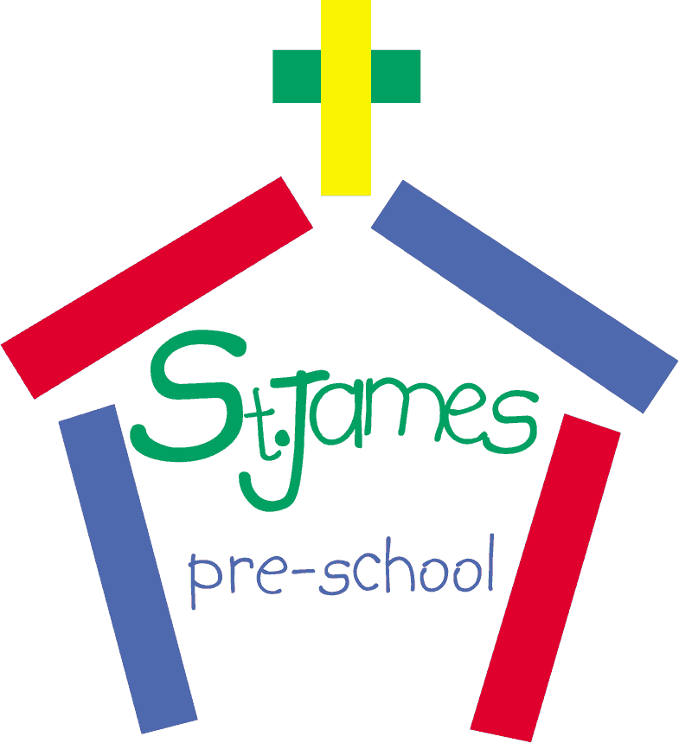**St. James’ Church Pre-School**

**Lockdown Policy**

***Policy Aim***

Lockdown procedures should be seen as a sensible and proportionate response to any external incident which has the potential to pose a threat to the safety of children and adults in the setting.

Links to Early Years Foundation Stage: Safeguarding and Welfare Requirements: Safety

and suitability of premises, environment and equipment: Safety 3.53, 3.56-3.65

***Lockdown reasons***

Lockdown procedures may be activated in response to any number of situations, but some of the more typical might be:

* A reported incident or disturbance in the local community (with the potential to pose a risk to children and adults in the setting)
* An intruder onsite (with the potential to pose a risk to children and adults in the setting)
* A warning being received regarding an environmental risk locally, of air pollution (smoke plume, gas cloud etc)
* A major fire in the vicinity of the setting
* The close proximity of a dangerous animal
* In instances including domestic breakdowns where estranged parties are attempting to abduct children.
* In instances where personnel, students, volunteers, or staff from within the setting become a threat to the well-being of others.
* A terrorist threat or national emergency.

***Lockdown Signal***

The setting has a recognisable lockdown signal that all staff can identify with and take immediate action. This signal is different to the emergency fire signal. The signal for St James Church Preschool is

Partial lockdown: Three short bursts of a whistle

Full lockdown: One long burst of a whistle

***Partial Lockdown***

A partial lockdown is a precaution aimed to keep children and staff safe while remaining indoors. This may be because of a reported incident/civil disturbance in the local community with the potential to pose a risk to children and staff in the setting. It may also be because of a warning being received regarding the risk of air pollution, etc. In a partial lockdown staff and children should remain in the building and all doors leading outside should be locked. No-one should be allowed to enter or leave the building; however, the setting can continue as usual.

What usually happens during partial lockdown?

* All outside activity to cease immediately, children and staff return to the building. All staff and children should remain in the building and external doors and windows should be locked.
* Free movement may be permitted within the building dependent upon circumstances.
* In the event of an air pollution or chemical, biological, or radiological contaminants issue, air vents, fans, heating, and air conditioning systems should be closed or turned off. Seal up all the cracks around doors and any vents into the room – aim to minimise possible access points of pollutants.
* Once the children, staff and volunteers are accounted for, the responsible person will conduct an on-going dynamic risk assessment basing their decision making primarily on advice received from the Emergency Services. All staff will be updated when applicable, and a written evidence log will be maintained throughout should it be required at a later stage.
* ‘Partial Lockdown’ is a precautionary measure and should be recognised that it places the pre-school in a state of readiness (whilst retaining a degree of normality), should the situation be further reported to have escalated.

If an emergency happens the setting manager must act quickly to assess the likelihood of immediate danger. In most cases the assumption should be that it is safer to stay put and place the setting into ‘lockdown’ until the emergency services arrive.

As soon as the emergency services arrive it is essential staff comply with instructions given.

Upon alert to lockdown:

* Stay calm.
* Ensure staff and children stay in their designated areas. Stay in the room you are working in, secure all doors and windows and await further instructions.
* Close curtains and blinds where possible.
* Stay away from windows and doors.
* Stay low and keep others calm, it might be an idea to rehearse this with children in an age-appropriate way, in the same way that you would rehearse fire evacuation. Lock-down should be rehearsed and recorded termly.
* Tune into a local TV or radio station for more information.
* Do NOT make non-essential calls on mobile phones or landlines.
* If the fire alarm is activated, remain where you are and await further instructions from emergency services unless the fire is in your area. In which case, move to the next room/area, following your usual fire procedures.

Be alert:

* Do NOT open the door once it has been secured until you are officially advised ‘all clear’ or are certain it is emergency services at the door. This is another element of your ‘lockdown’ procedure that can be practised in an age-appropriate way with the children to avoid them becoming anxious when staff do not respond to the doorbell in the usual way.
* Do NOT travel down long corridors.
* Do NOT assemble in large open areas.
* Do NOT call 999 again unless you have immediate concern for your safety, the safety of others, or feel you have critical information.

***Full Lockdown***

A full lockdown signifies an immediate threat to the setting and may be an escalation of a partial lockdown.

What usually happens during full lockdown?

* All children and staff should return to/stay in the building.
* External doors should be locked.
* Internal doors might be locked.
* Lock windows, draw blinds and curtains, so an intruder cannot see in.
* Staff and children to sit quietly out of sight and where possible in a location that would protect them from harm such as gunfire (bullets go through glass, brick, wood and metal). Consider locations behind substantial brickwork or heavy reinforced walls.
* Turn off lights, dim screens on display equipment.
* Turn off mobile phones (or at the least turn onto silent so they cannot give away your position).
* A register should be taken, and headcount completed of all staff and children at the setting. If any adult or child is found to be missing, a member of staff should check the garden and building and bring them back to the room as quickly and quietly as possible.
* Children should not be released to parents during a lockdown and staff should not leave the premises unless instructed to do so.
* A senior member of staff to ring 999 to report the incident and follow their instructions.
* If a group are on an outing when the incident occurs, a staff member to telephone them to tell them NOT to return to the nursery until the all-clear has been given. If it is safe to do, the group should stay where they are e.g. in the library/museum. If they are on their way back to the nursery, to stop and go back to the venue and stay there until advised otherwise. The staff on the outing to ring the police for advice.

The lockdown procedure will remain in force until it has been established from a member of the Emergency Services that the incident has been successfully resolved and no further risk is posed to the welfare and safety of the children / staff etc.

***Communication between parents and the pre-school during a lockdown***

Should a lockdown occur, it is advised that developments are communicated to parents / guardians as soon as is practicable and in some cases in agreement with the emergency services. Parents and carers will naturally be concerned and anxious. They should be given enough information to enable them to understand the potential outcome and when possible time frames so that they are reassured that the pre-school / emergency services understand their concern for their child’s welfare, and that everything possible is being completed to ensure their safety.

Parents:

* Should not contact the setting during lockdown as this could block telephone lines that are needed for contacting emergency services.
* Should not come to the setting during lockdown as this may place themselves and others in danger.
* Wait for the setting to contact them about when it is safe for them to come and collect their child.

Pre-school Lockdown procedures, especially the arrangements for communicating to parents, should be routinely shared with parents / guardians either by newsletter or via the pre-school’s website.

***Emergency Services***

It is vital that the communication lines remain open to the Emergency Services at all times as they are best placed to offer advice and assistance as a situation develops. A decision may be taken to cordon off the premises partially or as a whole by the Emergency Services. This will be dependent on the severity of the incident that has led to a Lockdown procedure taking effect. The emergency services will support the responsible person in the decision-making processes and the timing of communication to parents, the press etc.

***After lockdown***

The critical Incident policy will be followed, and the Critical Incident log used to create a full record of the event. As part of this, a notification of significant incident will be made to Ofsted within 14 days (preferably as soon as possible after the incident).

A letter to parents will be sent home as soon as possible following any serious incident to inform parents of the context of lockdown.

Policies and procedures will be reviewed as soon as possible after the event to identify any amendments that may be required as a result of the lockdown.

Suggested wording for message to parents:

Due to an incident, we have been advised by the emergency services to secure the premises and stay put until we are given the ‘all clear’. Please do not attempt to collect your child until it is safe to do so. We will let you know as soon as we are able when that is likely to be.

In the meantime, we need to keep our telephone lines clear and would appreciate your cooperation in not calling unless it is vital that you speak to us.

Legal framework

* Early years foundation stage (EYFS) statutory framework

|  |  |  |
| --- | --- | --- |
| This policy was adopted by | St James Church Preschool | *(name of provider)* |
| On | 21 January 2021 | *(date)* |
| Date last updated | May 2025 | *(date)* |
| Date last reviewed | May 2025 | *(date)* |
| Date to be reviewed | May 2026 | *(date)* |
| Signed on behalf of the provider |  | |
| Name of signatory | Nicola Tivey | |
| Role of signatory | Chair | |