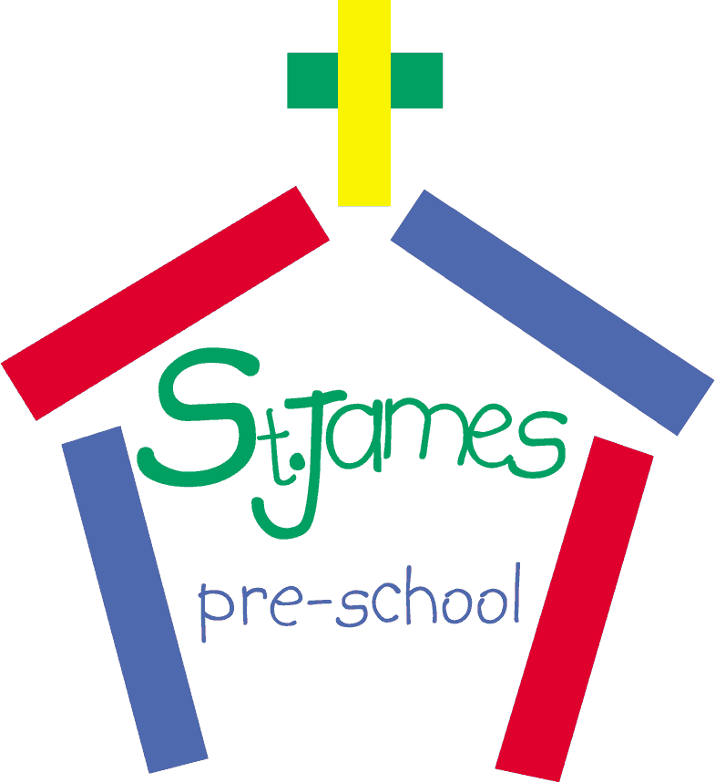**St. James’ Church Pre-School**

**Waiting List Policy**

***Summary***

This policy outlines the process for new child registrations for pre-school and hwo the waiting list is managed.

***Process***

1. Children’s names may be put on the Pre-School waiting list from 18 months old.
2. Children must be 2 years old before their start date.
3. A registration form must be completed. These are located in the Church Office or in the Pre-School or requested by emailing Admissions at [stjamesadmissions@hotmail.com](mailto:stjamesadmissions@hotmail.com). When completed they are returned to Pre-School or emailed to the Admissions Co-ordinator at the same email address.
4. Following the receipt of the completed Registration Form the child’s name is then added to the waiting list. There is a £10 non-returnable administration fee for this service. If this sum is not returned with the Registration Form, the treasurer requests payment in a follow up letter.
5. Once a completed Registration Form is received by the Admissions Co-ordinator the information given will be transferred onto the database. Details will include date of registration, the child’s full name, date of birth, address, telephone numbers (including mobile) parent’s name/s, email address, if any, the parent(s) signature and what sessions are preferred.
6. **Firstly,** children who are already attending pre-school and who have Nursery Grant Funding will be offered any extra sessions. **Secondly,** children who are already attending pre-school and are not funded will be asked if they would like any extra sessions. (Subject to these sessions being available).
7. Once places become available for the waiting list children the Admissions Co-ordinator will contact the families from the top of the waiting list (according to date of registration and date of birth) and offer them sessions. Generally, children start with two sessions a week. Parents/carers can defer these places until the following term if they desire. They will automatically stay on the waiting list for the next term.
8. Normally, the children at the top of the waiting list are already 3 years old. Although these children are new to the Pre-School and will possibly be funded (depending upon their date of birth), they will be entitled to the full funded number of sessions, providing these are available to offer at the time.
9. Once all the 3-year-olds have been accepted, we will then offer places to the younger children. These children will **not** be funded, although they can have 5 sessions a week if their parent/s are prepared to pay for them.
10. There are staff/child ratios to be adhered to, these are as follows:

**1 member of staff per 8 x 3-year-olds**

**1 member of staff per 4 x 2-year-olds**

These ratios are considered when offering sessions**.**

1. Once a child’s place has been accepted, a convenient visit date is arranged if they have not already visited. The child, along with a parent/carer will come into Pre-School for a one hour visit on the pre-arranged morning or afternoon session. The child is free to join in with all the activities set out for that session. The adult must remain with the child for the visit as they are not covered by the Pre-School Insurance until they are entered onto the Attendance Register. The adult must wear a mask during the whole visit.
2. The paperwork (prepared by the Admissions Co-Coordinator) will be given to the child’s parent at the time of the visit. This paperwork is to be taken home, read through and the relevant forms completed and returned before the child starts Pre-School. The “New Starter Pack” consists of the following:

* Prospectus
* Acceptance Form
* Introduce Us to Your Child Form
* Photograph Procedure Form
* Collection Password form
* Tapestry form
* COVID session rules form

1. Once all paperwork has been received back and the start date and sessions have been confirmed, the Admissions Co-ordinator wills send the parent a confirmation letter. This also outlines how invoicing is handled for session payment.

* Prospectus
* Acceptance Form
* Introduce Us to Your Child Form
* Photograph Procedure Form
* Collection Password form
* Tapestry form
* COVID session rules form

|  |  |  |
| --- | --- | --- |
| This policy was adopted by | St James Church Preschool | *(name of provider)* |
| On | 21 November 2021 | *(date)* |
| Date last updated |  | *(date)* |
| Date last reviewed |  | *(date)* |
| Date to be reviewed | December 2022 | *(date)* |
| Signed on behalf of the provider |  | |
| Name of signatory | Nicola Tivey | |
| Role of signatory | Chair | |